**Alphabet Neural Network Model**

**Overview**

A nonprofit foundation called Alphabet Soup is looking for a predictive model to use to evaluate what investments they make will be worth the investment. They have given us a CSV file with 34,000 applicants breaking down the applicant, their industry, identification columns, their requested funding, current income, and the status of the application. Alphabet Soup has come to us to try to develop a model that is at least 75% accurate .

**Results**

After using pd dummies to create a new dataset based on the original csv due to many of the categorical columns in the dataset.

**What variables are the target for your model**

The target variables is the new data set without the [IS_SUCCESFUL] column

**What variables are the features for your model**

The feature of the model is the [IS_SUCCESSFUL] values in the newly generated dataset

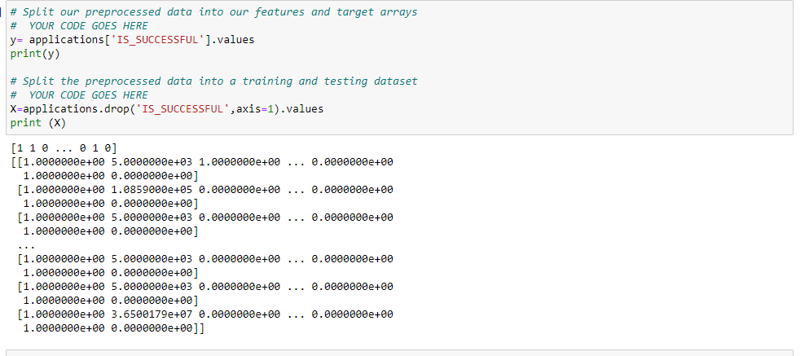

**What variables should be removed from the input data because they are neither targets or features**

Many of the columns in the dummy data set are neither features or targets due to them being categorical columns not affecting the test model

**How many neurons, layers ,and activation functions did you select**

2 hidden layers were used in the model along with 2 activation functions

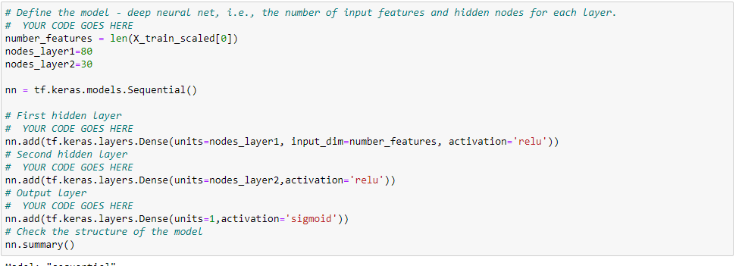but when attempting other models 3 layers with 2 functions, yielded a higher accuracy

**Were you able to reach the target model ?**

After 3 different modelsI was not able to reach the target model and could only get as high as 73%

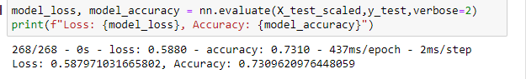

**What steps did you take in your attempts to increase model performance?**

After altering the units in other test models, what seems to work best is to increase the number of hidden layers within the model.

